**Four Rivers Healthy Community Presents**

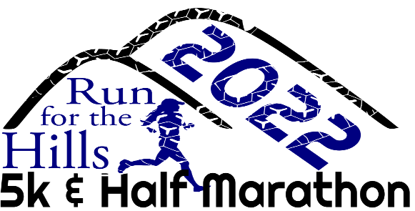

**OCTOBER 15TH**

June 2022

Four Rivers Healthy Community, Inc.

PO Box 923

Ontario, OR 97914

[www.4RHC.org](http://www.4RHC.org)

We are excited to announce the return of **RUN FOR THE HILLS**! This event features the half-marathon course as well as a 5k course for all ages and we are including a 1-mile walk this year! Run for the Hills is slated for October 15th. Once again, we will promote healthy and fit living with this family-friendly event. Our goal is to raise funds for Four Rivers Healthy Community, Inc. which supports scholarships, local needs grants, asset and project management to provide a safe and healthy place to live, work, raise a family, and enjoy life here in the Western Treasure Valley, both Oregon and Idaho! Four Rivers Healthy Community is a tax-exempt public charity.

We invite you to participate as a sponsor of Run for the Hills. Your sponsorship helps defray the cost of organizing the event and allows you to showcase your business while being involved in a fun community event. Funds received from sponsorships will be used to purchase t-shirts for registered race participants, medals for the top finishers, and refreshments for participants after the races. Any additional funding from sponsorships will be used to support our cause to enrich our community! There are several levels of sponsorship available as follows:

**Premier Sponsor Level $1000+**

• Large logo on back of race t-shirt

• Logo and contact information listed on race materials

• Display of sponsor supplied banner on race day

• Sponsor may set up a table of information at the event

• Verbal recognition on race day

• 4 complimentary race entries

**Gold Sponsor Level $500**

• Medium logo on back of race t-shirt

• Company name with link listed on race materials

• Sponsor may set up a table of information at the event

• Verbal recognition on race day

• 3 complimentary race entries

**Silver Sponsor Level $250**

• Small logo on back of race t-shirt

• Company name listed on race materials

• Verbal recognition on race day

• 2 complimentary race entries

**Bronze Sponsor Level $125**

• Company name listed on back of race t-shirt

• Company name listed on race materials

• Verbal recognition on race day

• 1 complimentary race entries

Thank you in advance for your consideration of becoming a sponsor of the Run for the Hills: Half Marathon, 5k, or 1-mile Fun Run! For more information, please contact: Cathy Yasuda at (208) 739-2360 or email: [rfth@4rhc.org](mailto:rfth@4rhc.org). Someone from our committee will be contacting you soon to follow up.

Sincerely,

Run for the Hills Planning Committee

*Your donation to this event may be tax deductible - consult with your tax professional. Four Rivers Healthy Community*

***Tax ID number****:* **20-2590790** *.*

